Quality Plan

*Identifying Fake News*

**1. Introduction**

This document constitutes the Quality Plan of the Fake News web extension. The quality management plan of Identifying Fake News will focus on the process and procedures for ensuring quality of the Identifying Fake News in terms of monitoring the project during the testing process.

**2. Scope of Work and Quality Objectives**

|  |  |
| --- | --- |
| Scope of work: | The study is about identifying fake news. The researchers will use web programming languages to create a web extension for identifying fake news. The gathered datasets will come from two online websites (kaggle.com, Opensources) The web extension will only work on the latest and upcoming versions Google Chrome and it will not work on any other browsers. This study is only limited in identifying fake news on social media sites and it will not identify fake news on other sites. |
| QA Requirement: | Reliability   * Web Extension that continuously identify fake news.   Consistency   * Conformity of the application.   Availability   * Availability of the service to be up 99.99% of the time.   Usability   * Easy to use.   Performance   * Responsiveness and speed of the extension to identify fake news |

**3. Project Organisation**

|  |  |
| --- | --- |
| Project Manager(s): | Marc Anthony Nares |
| Technical Writer(s): | Aleo Ralph C. De Leon  Wyatt Zeus H. Holgado |
| System Developer(s): | Aleo Ralph C. De Leon  Marc Anthony Nares |
|  |
| System Analyst: | Aleo Ralph C. De Leon  Marc Anthony Nares  Wyatt Zeus H. Holgado |
|  |  |
|  |  |
|  |  |

**4. Project Duration and Scheduling**

Start Date: 01/01/2017

Completion Date: 12/31/2018

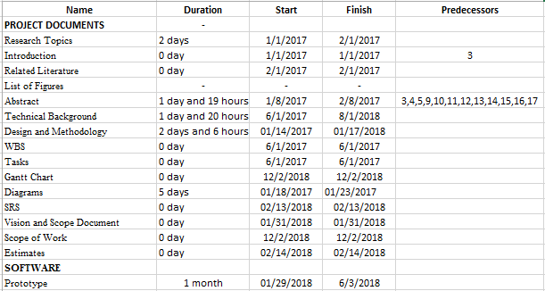Scheduling of Activities:

**5. Deliverables**

Deliverables specified for the project include:

1. Progress Reports
2. Vison and Scope Document
3. Project Charter
4. Scope of Work
5. WBS/Gantt
6. SRS
7. Estimates
8. Change Management
9. Risk Plan

**6. Review of Quality Plan**

The fake news identifier extension must be reviewed by the system analyst and developer to fix bugs and

**7. Document and Record Control**

The reported news data that was gathered from the users will be saved from our database.

The Quality Plan and Data Management Plan will be issued to all members of the consortium.

Project Progress Reports will be issued to the following:

List of names.

Aleo Ralph C. De Leon

Marc Anthony Nares

Wyatt Zeus H. Holgado

Prepared by: Date: 04/04/18

Aleo Ralph C. De Leon

Checked by: Date:

Approved by: Date: